Workshops at Infinity Ballet Conservatory
August 26th Friday 2:30-9:00 and Saturday 27th 9:30-4:00
Call for details 919-303-1105

Guest Teacher Christine Spizzo
Certified, ABT National Training Curriculum; adjunct faculty, UNC School of
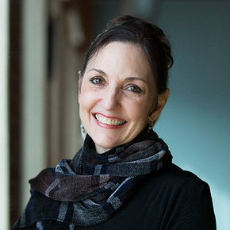
the Arts; ballet faculty, Dancers' Edge Dance Studio (Kernersville)

Born in Belleville, Illinois, dancer Christine Spizzo trained at the San Francisco Ballet School, the NC School of the Arts (now UNCSA), and at the School of American Ballet in New York. Upon graduation, she joined the National Ballet of Washington (DC), and the Ballet Repertory Company (NY), ultimately joining American Ballet Theatre in 1975. A soloist with ABT, Spizzo appeared in numerous Live From Lincoln Center and Dance in America telecasts, as well as the Herbert Ross films "The Turning Point" and "Dancers," and in Baryshnikov's "Nutcracker" and "Don Quixote" video films. Spizzo was a Principal dancer with Ballet Arizona from 1988-1990, and with the Nureyev & Friends North American tour in 1990. She performed in the Broadway company of "Phantom of the Opera" from 1990-2000. Also during that time, Spizzo was an adjunct professor at both NYU and SUNY/Purchase. In 1996, she served as Artistic Coordinator of ABT's inaugural Summer Intensive Program, and has remained a principal teacher in all subsequent ABT Summer Intensives in NYC and Austin, TX. Christine has been a Guest Teacher and stager of classical repertoire at various schools throughout North Carolina, and in New York, New Mexico, Arizona,
Connecticut, California, and Puerto Rico.

In 2000, Spizzo joined the dance faculty at UNCSA, where she worked for 10 years, receiving the Excellence in Teaching Award in 2006. She has taught in the School of the Arts' Preparatory Dance Program for several years, and will be rejoining UNCSA's faculty for Spring term, as an adjunct professor. Spizzo is also on faculty at the Dancers' Edge dance studio in Kernersville. Christine is the owner and co-founder, along with Mark McCullough, of Studio Elevé.

